Netflix Data Analysis

CREATE DATABASE Netflix

USE netflix

SELECT*FROM netflix_titles

Analysis:-

--1. Count the number of Movies vs TV Shows

SELECT type , COUNT(*) AS total_count
FROM netflix_titles
GROUP BY type

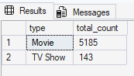

--2. Find the most common rating for movies and TV shows

with rating_count as (

SELECT type, rating, count(*) as total_titles,
rank()over(partition by type order by count(*) desc) as rank_no
from netflix_titles
group by type,rating
)
select type,rating,total_titles,rank_no
from rating_count
where rank_no=1

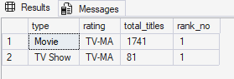

--3. List all movies released in a specific year (e.g., 2020)

SELECT *
FROM netflix_titles
WHERE release_year ='2020'AND type='Movie'
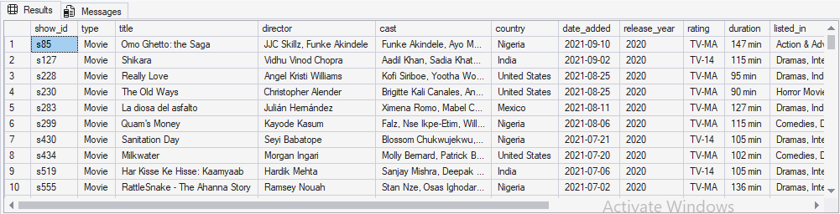

--4. Find the top 5 countries with the most content on Netflix

SELECT TOP 5 Country, COUNT(*) AS total_content
FROM netflix_titles
GROUP BY Country
ORDER BY total_content DESC

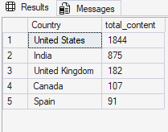

--5. Identify the longest movie

SELECT TOP 1 title,duration
FROM netflix_titles
WHERE type='Movie'
ORDER BY LEN(duration) DESC,duration desc

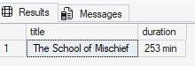

--6. Find content added in the last 5 years

SELECT Show_id,type,title,director,cast,Country,
DATEPART(YEAR, date_added) AS content_added,
release_year,Rating,duration,listed_in,description
FROM netflix_titles
WHERE DATEPART(YEAR, date_added) BETWEEN 2017 AND 2021
ORDER BY DATEPART(YEAR, date_added) DESC

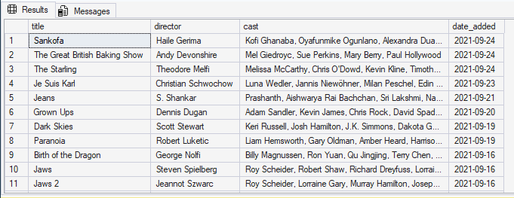

--7. Find all the movies/TV shows by director 'Rajiv Chilaka'!

SELECT * FROM netflix_titles
WHERE director LIKE '%Rajiv chilaka%'

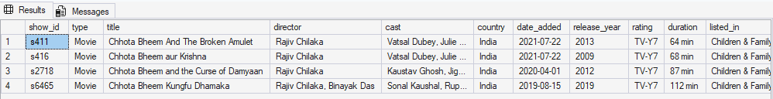

--8. List all TV shows with more than 5 seasons

SELECT*FROM netflix_titles
WHERE type='TV Show' AND duration >'5 seasons'

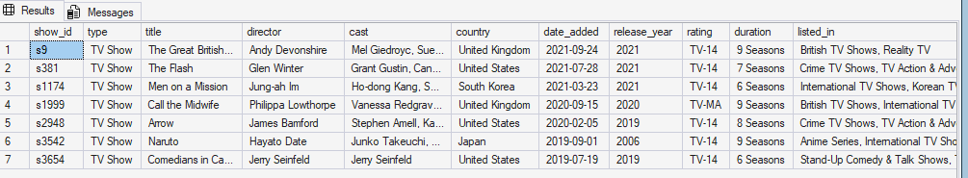

--9. Count the number of content items in each genre

SELECT listed_in AS genre,COUNT(*) AS total_content
FROM netflix_titles
GROUP BY listed_in
ORDER BY total_content DESC

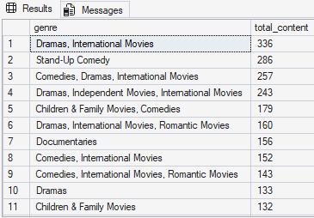

--10.Find each year and the average numbers of content release in India on netflix.
--return top 5 year with highest avg content release!

SELECT TOP 5
release_year,
COUNT(show_id) AS total_release,
CAST(
(COUNT(show_id) * 100.0) / (SELECT COUNT(*) FROM netflix_titles WHERE country = 'India')
AS DECIMAL(5,2)
) AS avg_release
FROM netflix_titles
WHERE country = 'India'
GROUP BY release_year
ORDER BY avg_release DESC
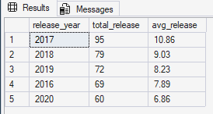

--11. List all movies that are documentaries

SELECT*FROM netflix_titles
WHERE type='Movie' AND listed_in LIKE '%documentaries%'

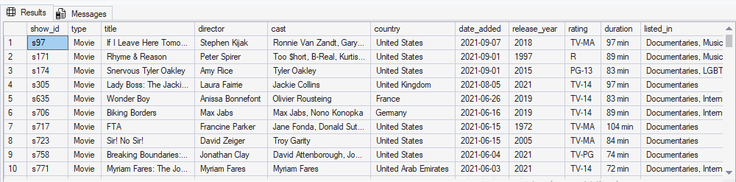

--12. Find all content without a director

SELECT COUNT(*) AS no_director FROM netflix_titles
where director = ''

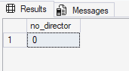

--13. Find how many movies actor 'Salman Khan' appeared in last 10 years!

SELECT COUNT(*) AS total_movies
FROM netflix_titles
WHERE type = 'Movie'
AND CAST LIKE '%Salman Khan%'
AND release_year>=year(getdate())-15

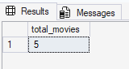

--14. Find the top 10 actors who have appeared in the highest number of movies produced in India.

SELECT TOP 10
LTRIM (RTRIM(value)) AS actor_name,
country,
COUNT(*) AS total_movies
FROM netflix_titles
CROSS APPLY STRING_SPLIT(cast,',')
WHERE type='Movie'
AND country='India'
GROUP BY LTRIM(RTRIM(value)),
country
ORDER BY total_movies DESC

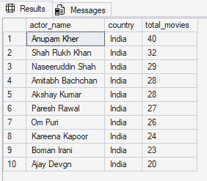

--15. Categorize the content based on the presence of the keywords 'kill' and 'violence' in
--the description field. Label content containing these keywords as 'Bad' and all other
--content as 'Good'. Count how many items fall into each category.

SELECT
CASE
WHEN description LIKE '%kill%' OR description LIKE '%violence%'
THEN 'Bad'
ELSE 'Good'
END AS category,
COUNT(*) AS total_content
FROM netflix_titles
GROUP BY
CASE
WHEN description LIKE '%kill%' OR description LIKE '%violence%'
THEN 'Bad'
ELSE 'Good'
END;



